, , Circles2

CH-Single CH-Ave CH-Mcquitty

1 NA NA NA

2 0.005363216 720.4045 697.4839

3 0.326675657 1062.4550 1067.4172

4 0.430131736 978.0728 889.8014

5 0.488446740 996.8213 872.0137

6 0.622593722 1022.1362 1064.9168

, , Circles4

CH-Single CH-Ave CH-Mcquitty

1 NA NA NA

2 0.008366146 0.1108671 3.234146

3 0.036633404 0.7238571 1.707240

4 0.202760335 1.3501610 1.907786

5 0.952002817 1.1890525 1.782265

6 0.773299567 1.5752380 1.586135

, , Cor2

CH-Single CH-Ave CH-Mcquitty

1 NA NA NA

2 1.408788 0.6613660 0.3830907

3 7.626047 0.4205687 0.5557264

4 6.869703 0.3037801 0.7481607

5 5.198815 0.4257507 0.9753830

6 4.237125 0.3961090 0.7984274

, , Cor3

CH-Single CH-Ave CH-Mcquitty

1 NA NA NA

2 0.9819194 0.4849672 1.2485084

3 1.6928498 0.3061487 1.0196224

4 1.6022357 0.2583907 0.8843989

5 1.2027382 0.4524449 0.8010896

6 1.1103746 0.3717019 0.6879367

, , Cor4

CH-Single CH-Ave CH-Mcquitty

1 NA NA NA

2 0.7386791 0.03387911 0.2997352

3 1.2157759 0.38826605 0.7431769

4 1.2232445 0.29123653 0.5538609

5 0.9376027 0.36332330 0.6491084

6 0.9239533 0.31106169 0.5730395

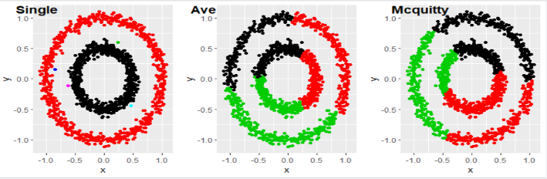



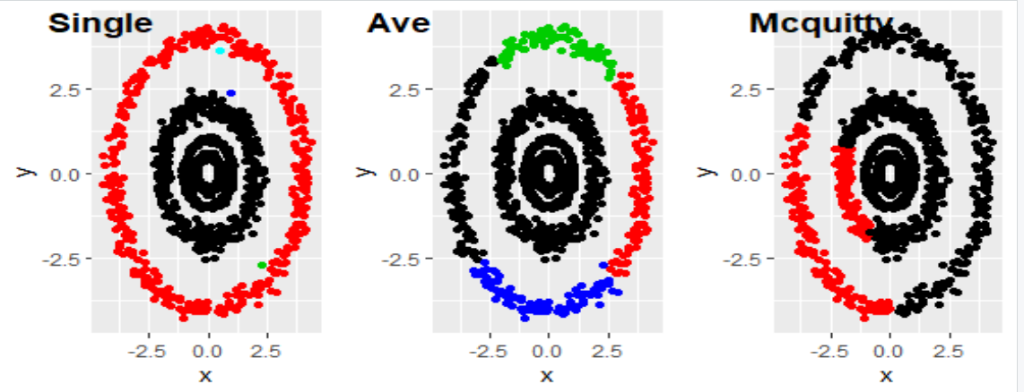



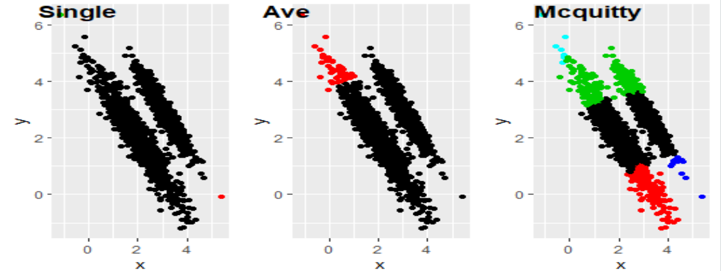



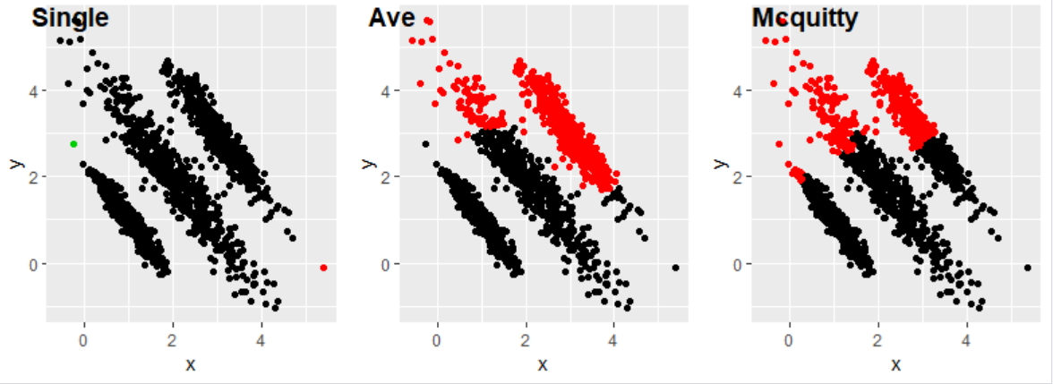



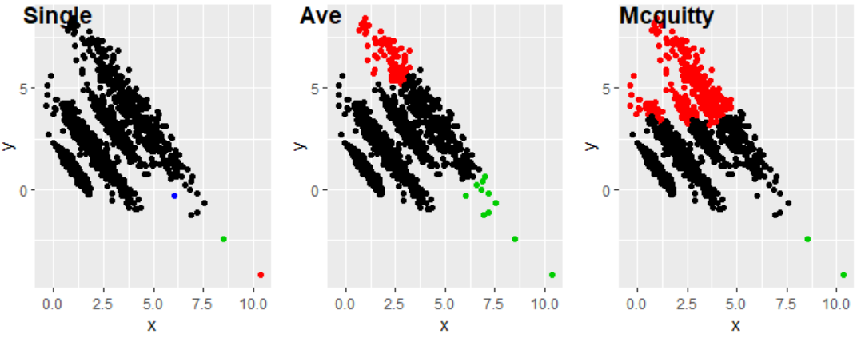



, , Cor5

CH-Single CH-Ave CH-Mcquitty

1 NA NA NA

2 0.9756038 0.2612403 0.8664441

3 1.3761713 0.1949635 1.0437362

4 1.4084984 0.1500494 0.7317164

5 1.0560903 0.4535111 0.9582634

6 1.0761351 0.4791212 0.7732579

, , GMM2

CH-Single CH-Ave CH-Mcquitty

1 NA NA NA

2 1.777584 0.7901870 0.02193296

3 3.542474 0.6433469 2.39182641

4 3.355435 0.4509834 2.01029064

5 2.696726 0.5813647 1.51823683

6 2.313679 0.9726835 1.23918406

, , GMM3

CH-Single CH-Ave CH-Mcquitty

1 NA NA NA

2 1.066950 0.9717404 2.709722

3 2.829862 0.5017839 2.573997

4 2.933458 0.3432917 1.864759

5 2.202097 0.7282800 1.428110

6 2.034284 0.6238752 1.271849

, , GMM4

CH-Single CH-Ave CH-Mcquitty

1 NA NA NA

2 1.195143 0.9150684 0.9757047

3 2.228531 0.4639731 1.0121486

4 2.254411 0.6959412 0.7023063

5 2.141434 0.8995106 1.4469979

6 1.903476 0.7403943 1.1619529

, , GMM5

CH-Single CH-Ave CH-Mcquitty

1 NA NA NA

2 0.1206375 1.9808825 3.081310

3 1.1434941 1.0070979 1.764833

4 1.2736673 0.9944068 1.252494

5 1.4811886 0.9381715 1.260426

6 1.2847741 0.9147841 1.033856

